Welcome to the weekly notices for St John's and All Saints'. If you have any items for inclusion then please let the Office know (office@stjohns-waterbeach.org.uk). If you want anything shared on social media then get in touch with Holli holli.bielby@gmail.com
Diary dates

Sunday 1 February
9:30am Community Breakfast Church (All Saints', Landbeach)
10:15am Holy Communion & Kids Church (St John's, Waterbeach)
4:00pm Sung Evensong (All Saints', Landbeach)
5:00pm Sunday One - Youth (Church Rooms, Waterbeach)
7:00pm Making Sense of the Gospel of St Matthew (Church Rooms, Waterbeach)

Tuesday 3 February
9:30am Praise & Play (Church Rooms, Waterbeach)

Wednesday 4 February
7:30am Morning Prayer (Church Rooms, Waterbeach)
11:30am Community Lunch (All Saints', Landbeach)

Thursday 5 February
8:00am Morning Prayer (Church Rooms, Waterbeach)

Saturday 7 February
10:00am Coffee and Conversation (Church Rooms, Waterbeach)
Opportunity to hear more about the work of Amos Trust from Chris Rose CEO
1:30pm Sustainable Wreath-Easy (All Saints', Landbeach)

Sunday 8 February
10:00am Holy Communion (All Saints', Landbeach)
10:15am Holy Communion & Kids Church (St John's, Waterbeach)

Monday 9 February
9:30am Toy Clean - Churchroom (Church Rooms, Waterbeach)

Tuesday 10 February
9:30am Praise & Play (Church Rooms, Waterbeach)

Wednesday 11 February
7:30am Morning Prayer (Church Rooms, Waterbeach)
11:30am Community Lunch (All Saints', Landbeach)

Thursday 12 February
8:00am Morning Prayer (Church Rooms, Waterbeach)

Sunday 15 February
8:45am Holy Communion (Said Service) (St John's, Waterbeach)
10:00am Morning Worship (All Saints', Landbeach)
10:15am All Age Holy Communion With Baptism (St John's, Waterbeach)
5:00pm Sunday Three! - Youth (Church Rooms, Waterbeach)
Notices

Volunteers!
With memories of New Year's resolutions long passed, new opportunities arise for making a difference.
Youth activities on Sunday One and Sunday Three are growing and need helpers to ensure sufficient adult attendance. Without volunteers to assist then this important ministry might not be able to continue. Please speak to Joel if you would like further information.
Administration support. Various tasks to aid our ministry to suit different time commitments. For example: weekly notices as part of a rota; service sheet printing ad hoc; reference checking... Please speak to a churchwarden for further information.
Sunday One! - Sunday 1st February
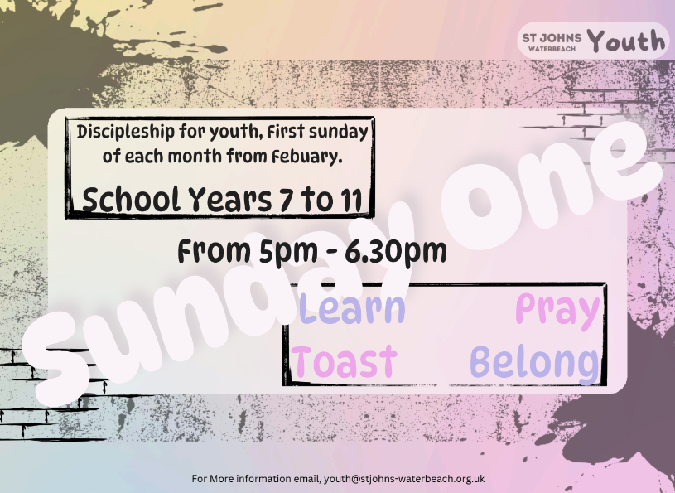
Making Sense of the gospel of St Matthew - Sunday 1st February
I'm planning to present on the First Gospel on 1st February, 7pm in the Church Rooms. St Matthew is the set gospel for the 2025/26 liturgical year, and this will be a good opportunity to get our gnashers into its theology, literary genres and cultures.
Revd Paul
Friends of All Saints', Landbeach (FOALs) - Thursday 5th February
Our first event this year will be the now-traditional choral concert by the Chapel Choir of our historic sponsors Corpus Christi College - giving their first outside performance of the academic year. They love to come here, where they can give this first performance among friends [and they get supper as well]. And we love to receive and support them in this way, and to enjoy some first-rate choral singing. Do please join us if you can at 7:00 for 7:30 'till 8:30 pm.

Coffee and Conversation - Saturday 7th February
Please join us on Saturday February 7th at 10am when Chris Rose, Amos Trust's Director will be coming to update us on the situation on the ground in Gaza and on the West Bank. He will be updating about the work of Amos and their local partners and the challenges faced by charities, NGO's and others trying work there today.
The morning will begin with coffee and cake and then Chris will speak to us and answer questions.
Please speak to Dorothy or Emma if you would like to find out more and follow this link to learn about the work of Amos Trust https://www.amostrust.org

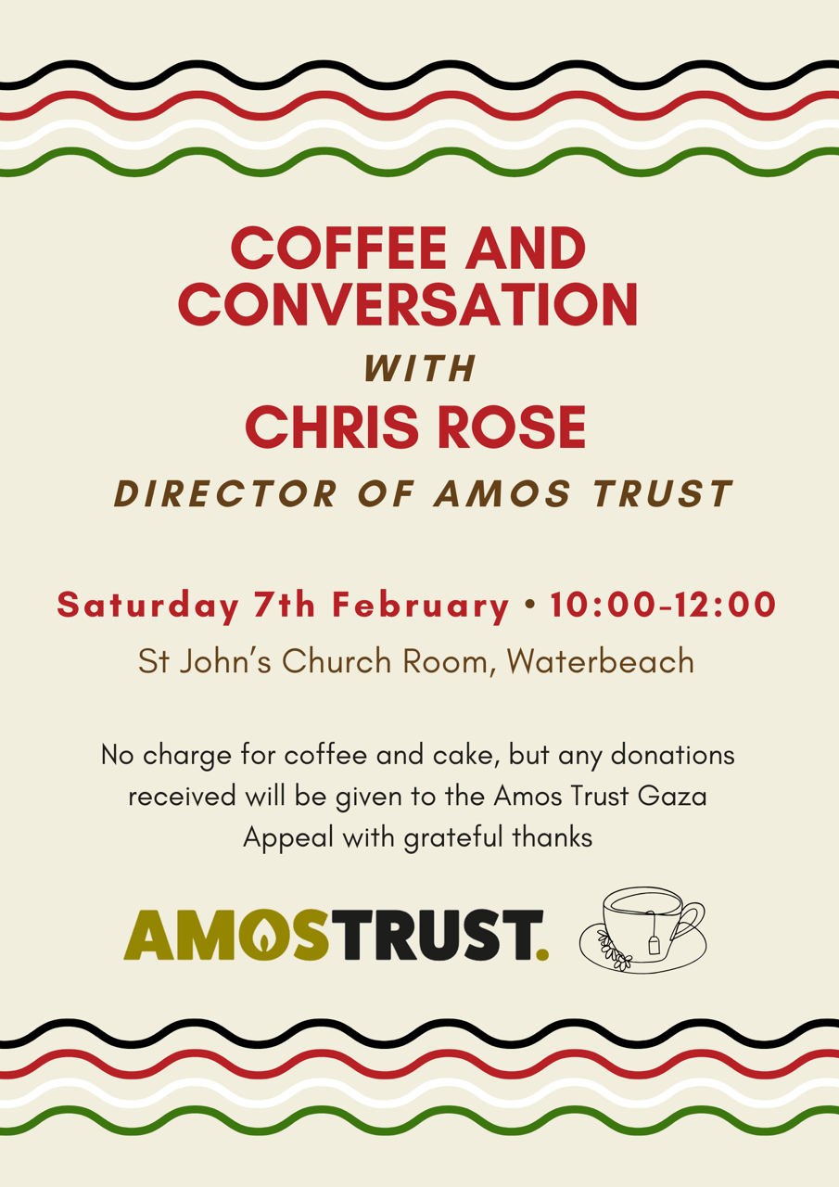
Sustainable Wreath-Easy - Saturday 7th February
Another Sustainable Wreath-Easy is taking place at All Saints', Landbeach, starting at 1:30 on Saturday, 7th February. A Valentine/Heart theme may pulse through, this time. We are likely to use Recycled/Roll-End decor this time but some Green and Growing options may be possible. Do feel free to provide contributions which can be shared.
Places are limited: please book as soon as possible. Free - but donations will help support community projects. angelastoryteller@gmail.com

New communion setting
We are going to introduce a new communion setting for the second Sundays. This is called 'The St Helen's Service' and you can see the composer introduce it at https://www.youtube.com/watch?v=JHWfy1F-nO4
This is NOT to replace the Mass of St Thomas (our usual setting) but to add a bit more variety when we have the choir present.
On February 8th, before the service, we invite members of the congregation to join us at 10 o'clock for an introduction to the Gloria and, if time, to some of the other movements. We'll do the same on the second Sunday in March (8th) and in April (12th).

Coffee and Reflection in Lent - Thursday 19th February
During Lent there will be 3 opportunities for us to meet in the Church Room for coffee as well as a time to reflect in Lent with a short act of worship or Holy Communion.
10.30am – Coffee, cake and conversation
11.45 am – Lent Reflection or Holy Communion (see below)
- Thursday 19 February – Coffee and Lent Reflection
- Wednesday 4 March – Coffee and Holy Communion
- Thursday 19 March – Coffee and Lent Reflection
All adults are welcome to drop in for any part of the morning.
If you want more details please email Janet Glover (janet@theglovers.name)

Sponsor a fruit tree in the Old Burial Ground
We are planning to plant six Apple trees in the Old Burial Ground to improve the biodiversity, provide fruit and improve the aesthetic. The trees will be sourced from the East of England Apples and Orchards Project and will be at least four different varieties to provide a long season of fruiting from early August through to late September.
The cost of each tree is £25 to include the tree and a planting pack of stake and tree guard.
There will also be a cost of employing help to ensure the trees are well planted and equipment to ensure the trees are watered sufficiently while they establish.
If you would like to make a donation towards this project, please use this payment link https://pay.sumup.com/b2c/Q2MN8F0W
For more information, or to donate cash, please contact Dorothy d.druitt@ntlworld.com or Richard richard.stobart@gmail.com

Safeguarding Surgery - Sunday 22nd February
Every 4th Sunday after morning church (11:30-12), Holli Bielby our Parish Safeguarding Officer will be available to answer any questions or concerns; help complete training; get support with forms; or simply chat about volunteering and safeguarding requirements.

Making Sense of the Big Story of the Bible
1st March, 12th and 26th April, The Revd Professor Steve Walton will be presenting on the big story of the Bible. Holy Scripture comprises texts written over hundreds of years, in a broad range of genres and reflecting diverse cultures - and this cultural, literary and historical distance can create a dissonance with our Western postmodern worldviews.
Steve will provide us with a number of hooks on which we can hang the big story of God and humankind. After the first session, Steve will review and seek feedback for the next two sessions. The second and third sessions will go ahead if we get a decent takeup for the first session!



Contact Details
Priest in Charge:
The Rev'd Paul Butler - revpbutler@gmail.com Tel: 07903 904 599
Associate Priests:
The Rev'd Janet Glover - pastoral@stjohns-waterbeach.org.uk
The Rev'd Jackie Metcalfe - jacques701@gmail.com
The Rev'd Sue Butler
Curate:
The Rev'd Sarah Newns - revsarahnewns@gmail.com
St John's Church Wardens: churchwarden@stjohns-waterbeach.org.uk
Andrew Glover - Tel: 07946 508727
James Bielby - Tel: 07967 047354
All Saints' Licensed Lay Minister / Warden:
Ray Gambell - ray.gambell@btinternet.com Tel: 01223 860757
All Saints' and St John's Licensed Lay Minister:
Jane Oakes - janemaryoakes@gmail.com
Children, Youth and Families Ministry:
Sarah Edwards - SEdwards@stjohns-waterbeach.org.uk
Joel Moore - youth@stjohns-waterbeach.org.uk
Safeguarding Officer:
Holli Bielby - safeguarding@stjohns-waterbeach.org.uk Tel: 07779 408588
St John's Treasurer:
Dove Feng - treasurer@stjohns-waterbeach.org.uk
Office:
office@stjohns-waterbeach.org.uk Tel: 01223 344374
Church Room Bookings:
Adrian Wright - Tel: 01223 861846

