Welcome to the weekly notices for St John's and All Saints'.
If you have any items for inclusion then please let the Office know (office@stjohns-waterbeach.org.uk).
If you want anything shared on social media then get in touch with Holli holli.bielby@gmail.com
DIARY DATES

Sunday 10 August
10:00am Holy Communion (All Saints', Landbeach)
10:15am Holy Communion (St John's, Waterbeach)

Wednesday 13 August
7:30am Morning Prayer (St John's, Waterbeach)
11:30am Community Lunch (All Saints', Landbeach)

Thursday 14 August
8:00am Morning Prayer (St John's, Waterbeach)
2:30pm Afternoon Tea (Church Rooms, Waterbeach)

Friday 15 August
11:00am VJ Day Memorial (St John's War Memorial)
7:00pm Organ Concert (Friends) (St John's, Waterbeach)

Sunday 17 August
9:00am Holy Communion (Said Service) (St John's, Waterbeach)
10:00am Morning Worship & VJ Commemoration (All Saints', Landbeach)
10:15am All Age Holy Communion (St John's, Waterbeach)

Tuesday 19 August
8:00pm Prayer Engine (St John's, Waterbeach)
6:30pm Youth - Fire Pit Evening (St John's, Waterbeach)

Wednesday 20 August
7:30am Morning Prayer (St John's, Waterbeach)
11:30am Community Lunch (All Saints', Landbeach)

Thursday 21 August
8:00am Morning Prayer (St John's, Waterbeach)

Sunday 24 August
9:30am Breakfast Church (St John's, Waterbeach)
10:00am Holy Communion (All Saints', Landbeach)
10:15am Holy Communion (St John's, Waterbeach)

NOTICES

Vicar's Leave
I'll be taking leave from 11th August to 10th September (inclusive).
Janet and Jackie have kindly agreed to cover pastoral requests, and Jackie will cover funeral requests. Andrew will continue to monitor the office@ These details will be provided in my Out-Of-Office.

St John's and All Saints' Staycation 3-5 October - Bookings OPEN!
Bookings for the weekend at home (aka Staycation) are open, use the link here https://thechurchofstjohnwaterbeach.churchsuite.com/-/forms/5opmyv1j
In brief:
Friday evening
In the evening (from 7pm) we will gather for cake & dessert, an introduction and some informal activity.
Saturday
Nick Ladd will lead 3x 90min sessions from 9:30am to 4:30pm (at Landbeach Village Hall) with time for a walk or relaxation after lunch. Bring your own packed lunch. Drinks provided.
Dinner at various host people's homes in the evening.
Children's activities (at Landbeach church) throughout the day with Tim Blake (former children's worker at Histon)
Sunday
Nick will preach at the 10:15am service at St John's
Afterwards there will be a lunch provided
Suggested cost is £40 (Adults), £20 (Youth) and £10 (Children). Bursaries available and Donations to support others accepted!
Any questions, suggestions or concerns please speak to Toby, Katy, Andrew or Paul
Afternoon Tea - Thursday 14th @ 2:30pm
We have our monthly afternoon tea this Thursday in the church rooms from 2:30pm.
All welcome. If anyone would like a lift then do please let us know.
VJ Day - 80th Memorial
Following the service at 11 am on 15th August at St. Johns War Memorial, all are invited to Waterbeach Lodge for coffee and eats on the balcony, where veterans will be present and we can continue part of our service there
There will be a Commemoration Service at the 10am service at All Saints' Landbeach on Sunday 17th August.

Organ Concert - 15th August
The Friends of St John's will be hosting an organ concert in the church on the evening of Friday 15th August starting at 7pm. The concert will be performed by the very talented Mark Slatter. Some of you will remember Mark from when he played the organ in the Sunday service.
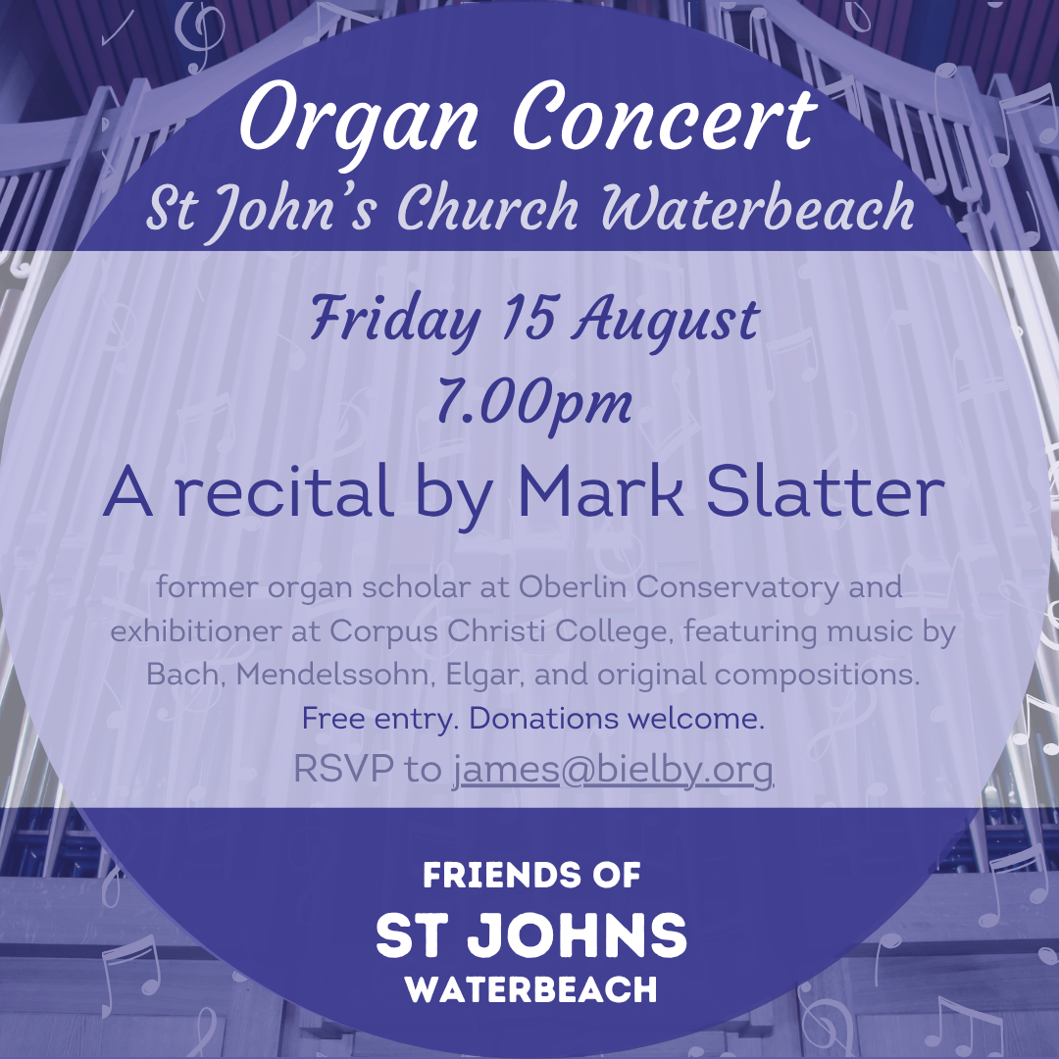

Fire Pit Evenings - 19th August
Youth event for over the summer holidays
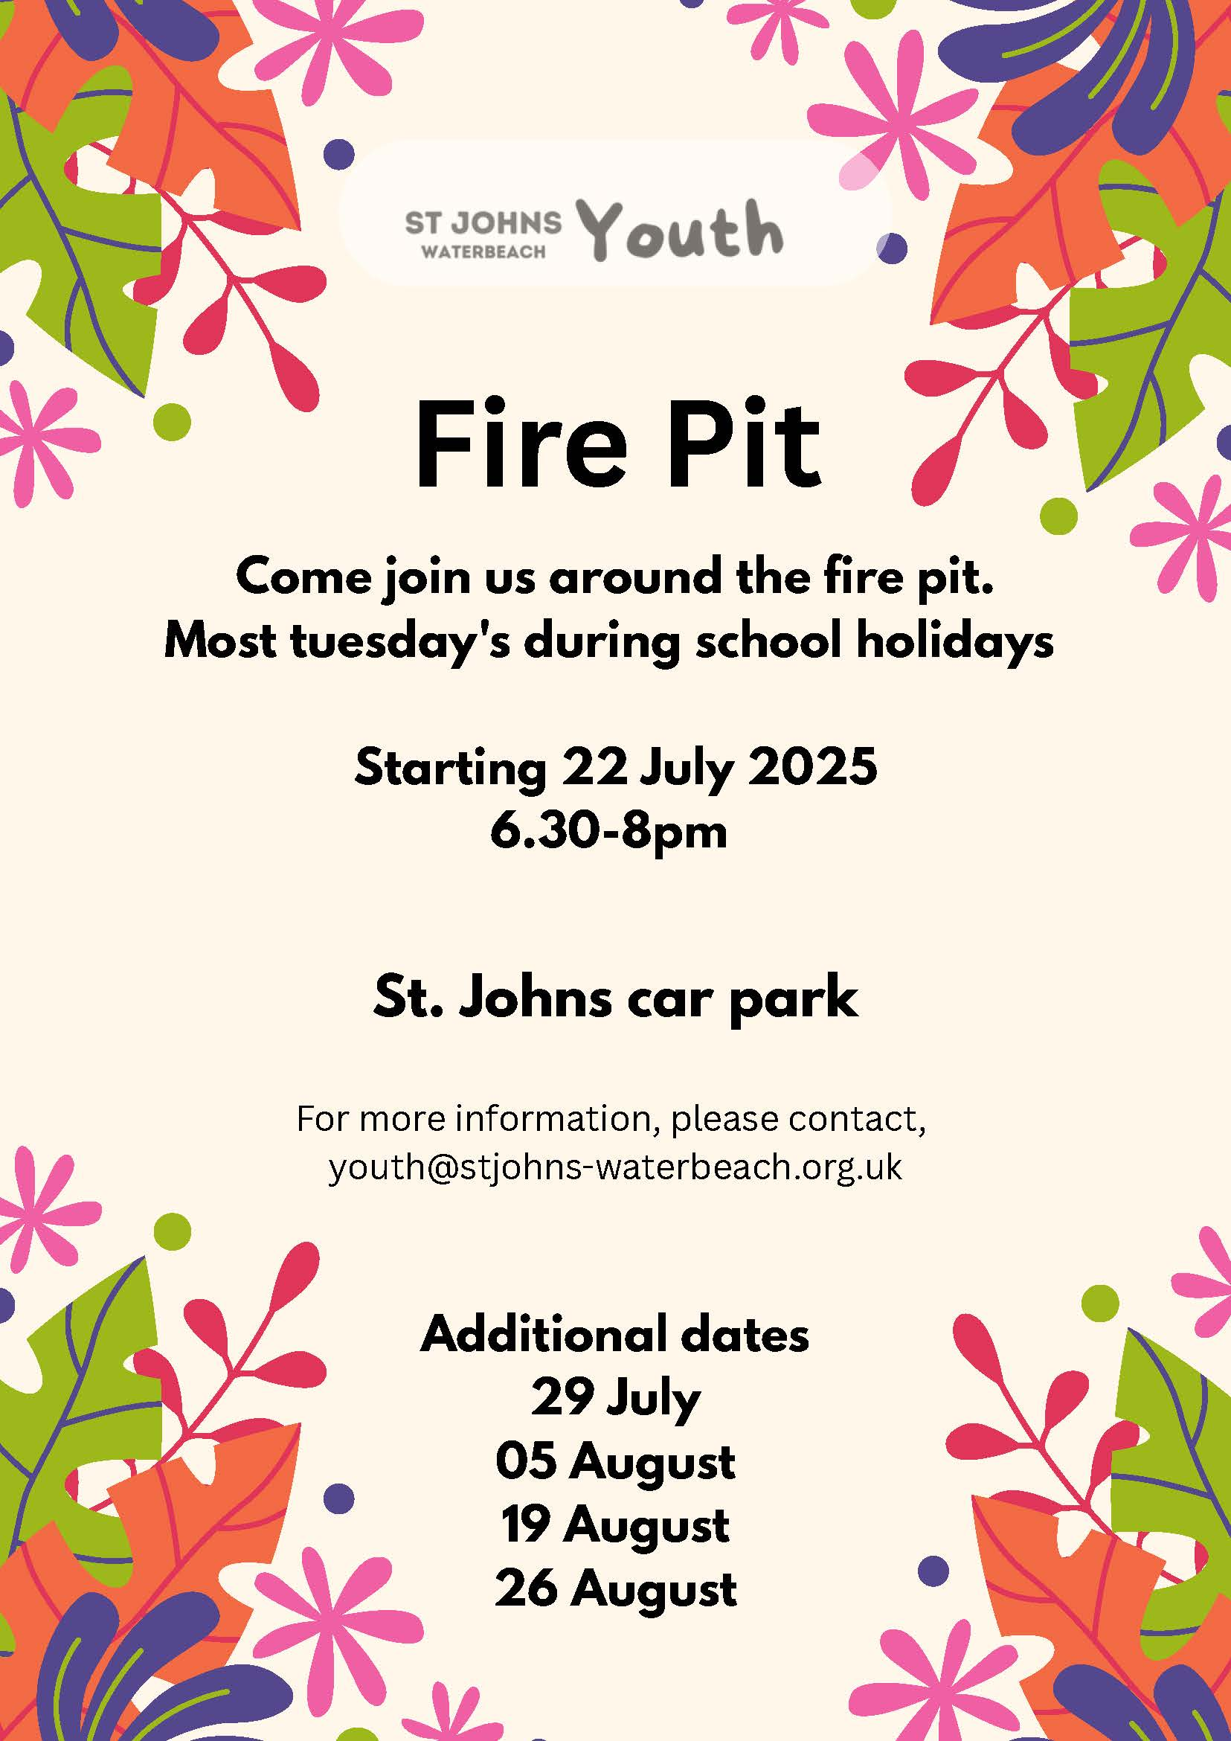

ADVANCE NOTICES & ASSISTANCE REQUIRED

Breakfast Church in August - 24th
This will be a simpler breakfast of pastries, fruit, tea and coffee. Please let Kirsty know if you are able to help set up, serve refreshments and/or clear up on this day.
Youth Alpha - Starts September 7th


Season of Creation - Contributions please...
The Season of Creation begins on 1 September 2025. Once again we will be setting up displays in church which will provide an opportunity to reflect upon our relationship with God, the world and our neighbours.
The theme this year is Peace with Creation and the chosen Bible passage is Isaiah 32: 14 -18.
We would welcome contributions of photos, paintings, poetry or prose that might be used in these displays.
These can be brought to church during August and given to one of the eco- team.

Creationtide Sunday, Church Room, 28th September @ 7pm
Dr Ruth Bancewitz from the Faraday Centre will be presenting at Making Sense on Even the Stones Would Cry Out: Making Peace with Creation
Jesus knew that all of creation has a relationship with its creator, so even inanimate objects have their way of expressing praise to him. Through our increasing separation from the rest of creation, many of us have missed this aspect of Christian faith. In contrast, recent ecologically conscious movements have embraced a perspective of nature that sees non-human or even non-living entities as valuable in themselves, ascribing something akin to personhood to them. Ruth will explore what the Bible has both to affirm and challenge about this view, helping us to make peace with creation. Come and join the discussion, either as a Christian or as someone curious to join the conversation.
You can find Ruth's bio here: https://www.faraday.cam.ac.uk/about/people/dr-ruth-bancewicz/?type=directors
Wreath-Easy!
· Make a low-cost, seasonal wreath at our free workshops on Sept 20 or 21st at All Saints' Church Landbeach. Bring your own scissors, pliers and apron.
Info: https://www.achurchnearyou.com/church/13835/news/
· Choose Saturday 10:30-11:30; or 2:00-3:00; or Sunday 2:00-3:00. Arrive early!
· Children over age 8 may attend only if accompanied by a responsible adult.
· Make a 20cm door-wreath for a Season of your choice using Sustainable materials. Part of the Harvest and Creationtide celebrations across Landbeach community.
Donations towards location costs and refreshments are welcome.
Book in advance to be sure of a place: angelastoryteller@gmail.com 07884465648

Bitter & Sweet, Graham Kendrick concert
Graham Kendrick, the singer-songwriter, will be in concert at St John's Waterbeach on Friday 19th December at 7pm - this is part of his Bitter-Sweet Christmas tour with Patrick Regan OBE. There are 160 seats available and tickets are likely to be in demand. The tickets cost £10 (£8 for u18s)
Tickets are selling fast, over 100 already sold!!
The URL of restored-uk.org/bitter-and-sweet
If you are able to assist with the organisation on the evening (catering, stewarding, technology etc) then please contact the Churchwardens. Reserved seats and discounts available to those that help!!

CONTACT DETAILS
Priest in Charge:
The Rev'd Paul Butler - revpbutler@gmail.com Tel: 07903 904 599
Associate Priests:
The Rev'd Janet Glover - pastoral@stjohns-waterbeach.org.uk
The Rev'd Jackie Metcalfe - jackie@stjohns-waterbeach.org.uk
The Rev'd Sue Butler
Curate:
The Rev'd Sarah Newns - revsarahnewns@gmail.com
St John's Church Wardens: churchwarden@stjohns-waterbeach.org.uk
Andrew Glover - Tel: 07946 508727
James Bielby - Tel: 07967 047354
All Saints' Licensed Lay Minister / Warden:
Ray Gambell - ray.gambell@btinternet.com Tel: 01223 860757
All Saints' and St John's Licensed Lay Minister:
Jane Oakes - janemaryoakes@gmail.com
Children, Youth and Families Ministry:
Kirsty Morris - KMorris@stjohns-waterbeach.org.uk
Sarah Edwards - SEdwards@stjohns-waterbeach.org.uk
Joel Moore - youth@stjohns-waterbeach.org.uk
Safeguarding Officer:
Holli Bielby - safeguarding@stjohns-waterbeach.org.uk Tel: 07779 408588
St John's Treasurer:
Andrew Cotton - treasurer@stjohns-waterbeach.org.uk
Office:
office@stjohns-waterbeach.org.uk Tel: 01223 344374
Church Room Bookings:
Adrian Wright - Tel: 01223 861846

